**Abstract Class**

**1.Example: Java Abstract Class and Method**

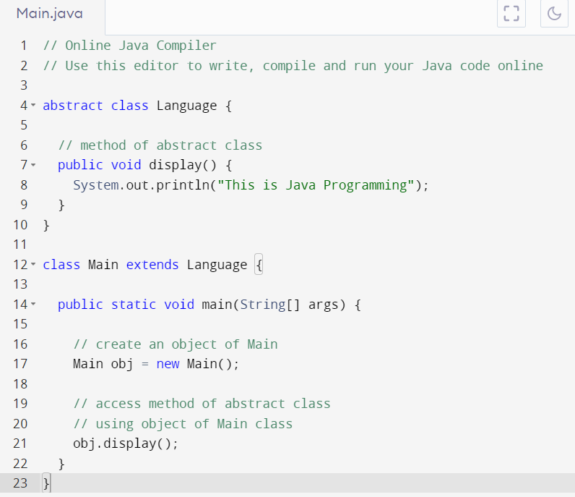

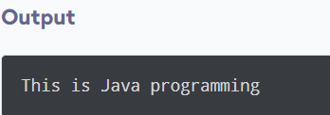

## **2. Implementing Abstract Methods**

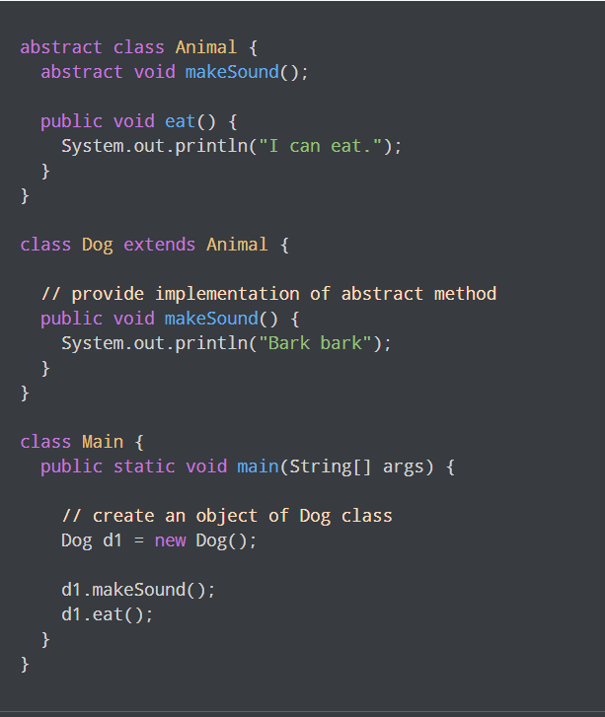

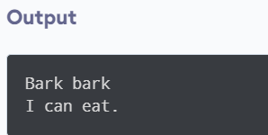

### 3: Java Abstraction

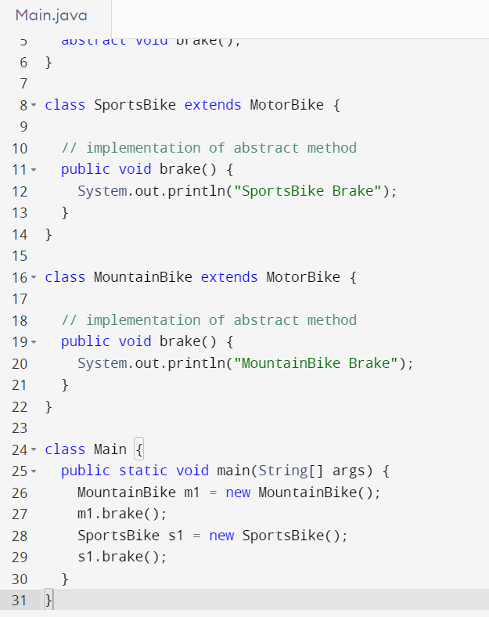

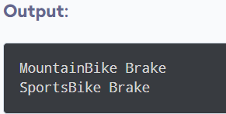

### 4.  real scenario of Abstract class

### 

**Output:**

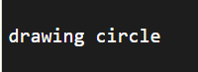

**5.Write a Program of an abstract class that has abstract and non-abstract methods .**

